**MINI PROJECT**

**(2021-2022)**

**DATABASE MANAGEMENT SYSTEM**

**MID-TERM REPORT**



**Institute of Engineering & Technology**

**Submitted by**

**Abhijeet Nag: abhijeet-nag**

**Shashwat Pandey: shashwattpandeyy**

**Avi Vivek: avi-vivek**

**Abhishek Rai: abhishekrai1**

**INDEX**

1. **Abstract**
2. **Introduction** 
   1. Definition
   2. Description
3. **Problem definition**
4. **Objectives**
5. **Some Screenshots**
6. **References**

**Abstract**

This report lays out a project plan for the development of the “DATABASE MANAGEMENT SYSTEM” open source repository system.

The intended readers of this document are current developers working on “DATABASE MANAGEMENT SYSTEM”. The plan will include but is not restricted to, a summary of the system functionality, the scope of the project from the perspective of the “DATABASE MANAGEMENT SYSTEM” team (Our team and my mentors), the process by which we will develop the project, and metrics and measurements that will be recorded throughout the project.

**Introduction**

**Definition:** This is the app for patients who want to take appointment from a particular doctor so by using this app that user easily get all details at which time doctor is free and what is the consultancy fees of that doctor.  
  
**Description:**In this project we are creating an app and an admin panel app can use by everywhere and anyone can use this app. This app solves a huge problem which the person facing this time. That is If a patient wants to book an appointment in a hospital had to cover a long distance to reach that hospital and if that particular doctor was not present there or the consultation fees are so high or the doctors timing is different so only the patient suffer.

By this app any patient all over the world can see which doctor is free at which place at what time and what is the consultation fees of that doctor so this is the use of our app.

Our admin panel also plays a huge role by this admin panel any clinic/ hospital can register itself and update their doctors details so their patient is happy.

There are 3 such applications available:

**1. Sminq: -**

This application is used for Book appointments online. Access last minute bookings at the most popular doctors without the wait.

**FEATURES: -**

1. Book doctor appointments.
2. View live status of your queue remotely.

**2.Procto: Online doctor consultations and appointment:**

Practo is a health app where you can ask a doctor free health questions and get expert answers to your health queries. With the largest network of doctors and healthcare providers from top clinics and hospitals, Practo serves users PAN India, including all metropolitan cities and Tier 2 cities like Lucknow, Surat, Kanpur, Ludhiana, Nashik, and Ernakulam.

**FEATURES: -**

1. Find doctors/medical specialists in your area by name, speciality, or clinical procedure
2. Explore patient stories, doctor’s online profile, locations, fees & experiences
3. Enjoy hassle-free online doctor appointment booking.

**3.Mindester**:**Doctor appointment app** is the future of modern medicine. It empowers doctors, patients and healthcare enterprises to capitalize on a simple but powerful technological device i.e the smartphone. On-demand doctor booking apps can help the patients connect to doctors instantly, share reports and get prescriptions from home. Our [mobile app development](https://mindster.com/mobile-app-development-services/) team with an industry-wide experience of more than a decade is well equipped for this task

**FEATURES:**

1. Health clinics can expand their scope of health services with our **doctor scheduling apps** and other mobile solutions.
2. Keep track of your patient's health with our powerful apps that makes it easy to communicate over an internet connection.
3. Convenient time slot can be chosen after confirming the doctor availability

**About the Project**

**A) WHAT DO WE WANT TO CREATE?**

A Doctors Database Management System.

**B) WHAT IS OUR IDEA ABOUT?**

It is an Android/IOS based application that show database off all doctors.

**1) WHO?**

**1.1) Who does our application target?**

Our application targets the Patients who are living in rural places which have to move long distance to reach particular hospital/clinic.

**2) WHAT?**

**2.1) What is the boundary of the problem?**

Almost Every patient have common problem before consultation to the doctor.

**2.2) What is the issue?**

The issue is that at some places their was any emergency and doctor has to cancel his appointment so in that situation all patient has to suffer.

**2.3) What is the impact of the issue?**

According to research 40% people lose their time in waiting for doctor as well as money while travelling and after that don’t get result.

**2.4) What will happen if this problem is fixed?**

As soon as the problem is fixed the people will start save their lot of time and money.

**3) WHEN?**

**3.1) When did the issue start to occur?**

This issue occurs from long time.

**3.2) When does it need to be fixed?**

It needs to be fixed right now! As many of the patients will suffer from that problems.

**4) WHERE?**

**4.1) Where does this issue occur?**

This issue occurs in every cities where hospital/clinic is present.

**Android || IOS Technical Support**

**Technologies Languages :**  FLUTTER, DART, FIREBASE, NODE.JS, HTML, CSS.

**Android app development platform:** Android Studio, Virtual device, Web.

**Server platform:** Windows , Web.

**Introduction to the Development tool “Android Studio”**

Android Studio is the official integrated development environment(IDE) for Android platform development. Android Studio is freely available under the Apache license. Android Studio is designed specifically for Android development. Android application development can be started on either of the following operating systems – Microsoft® Windows® 8/7/Vista/2003 (32 or 64-bit). Mac® OS X® 10.8.5 or higher, up to 10.9 (Mavericks). GNOME or KDE desktop. All the required tools to develop Android applications are open source and can be downloaded from the Web. Following is the list of software's that is needed before starting Android application programming. Java JDK5 or later version Java Runtime Environment (JRE) 6 Android Studio.

**DATABASE MANAGEMENT SYSTEM**

**Front page:**

1. ADMIN PANEL SIGNIN PAGE

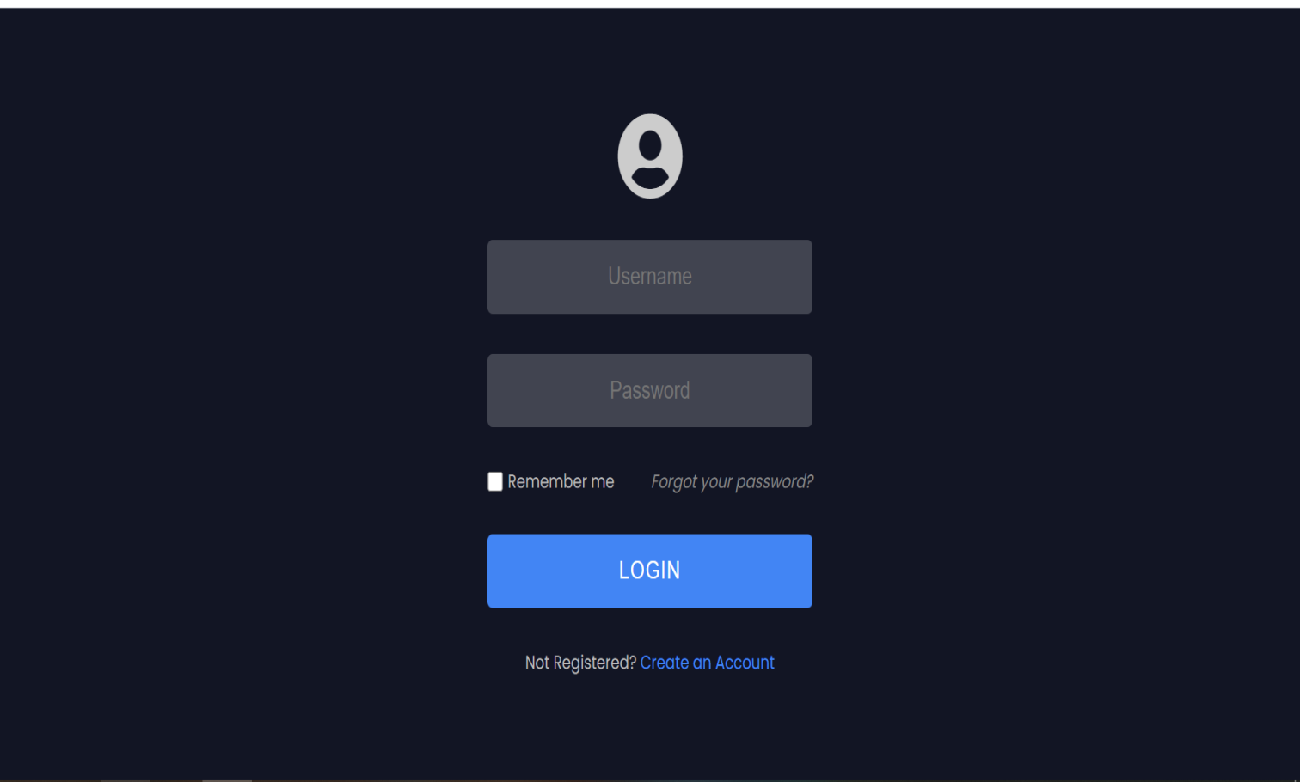

2. ADMIN PANEL SIGNUP PAGE

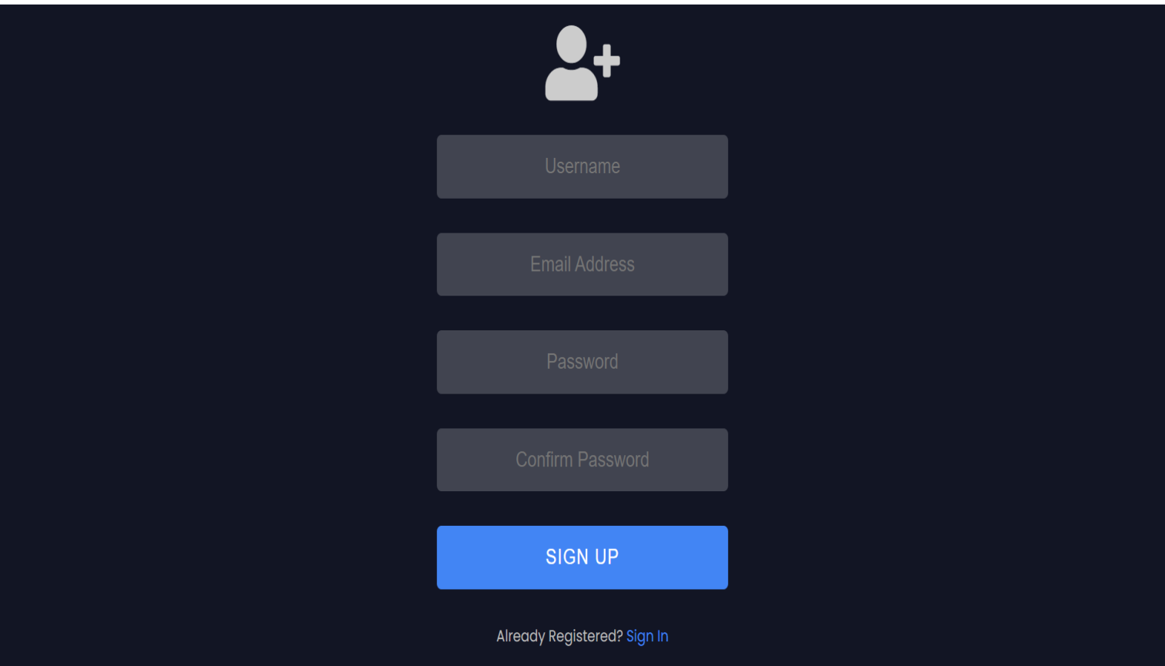

**Form:**

1. Dialog Box

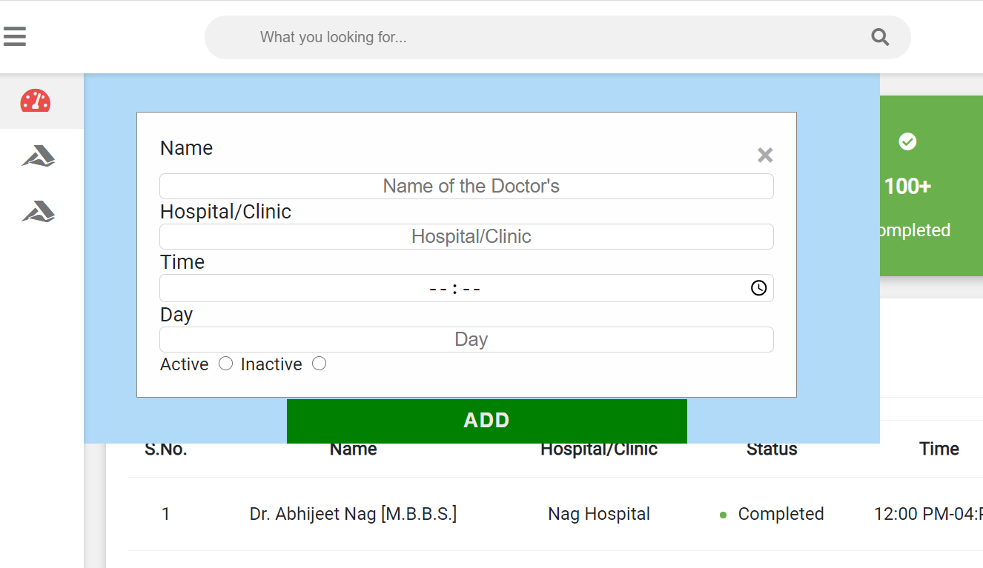

**Index Page:**

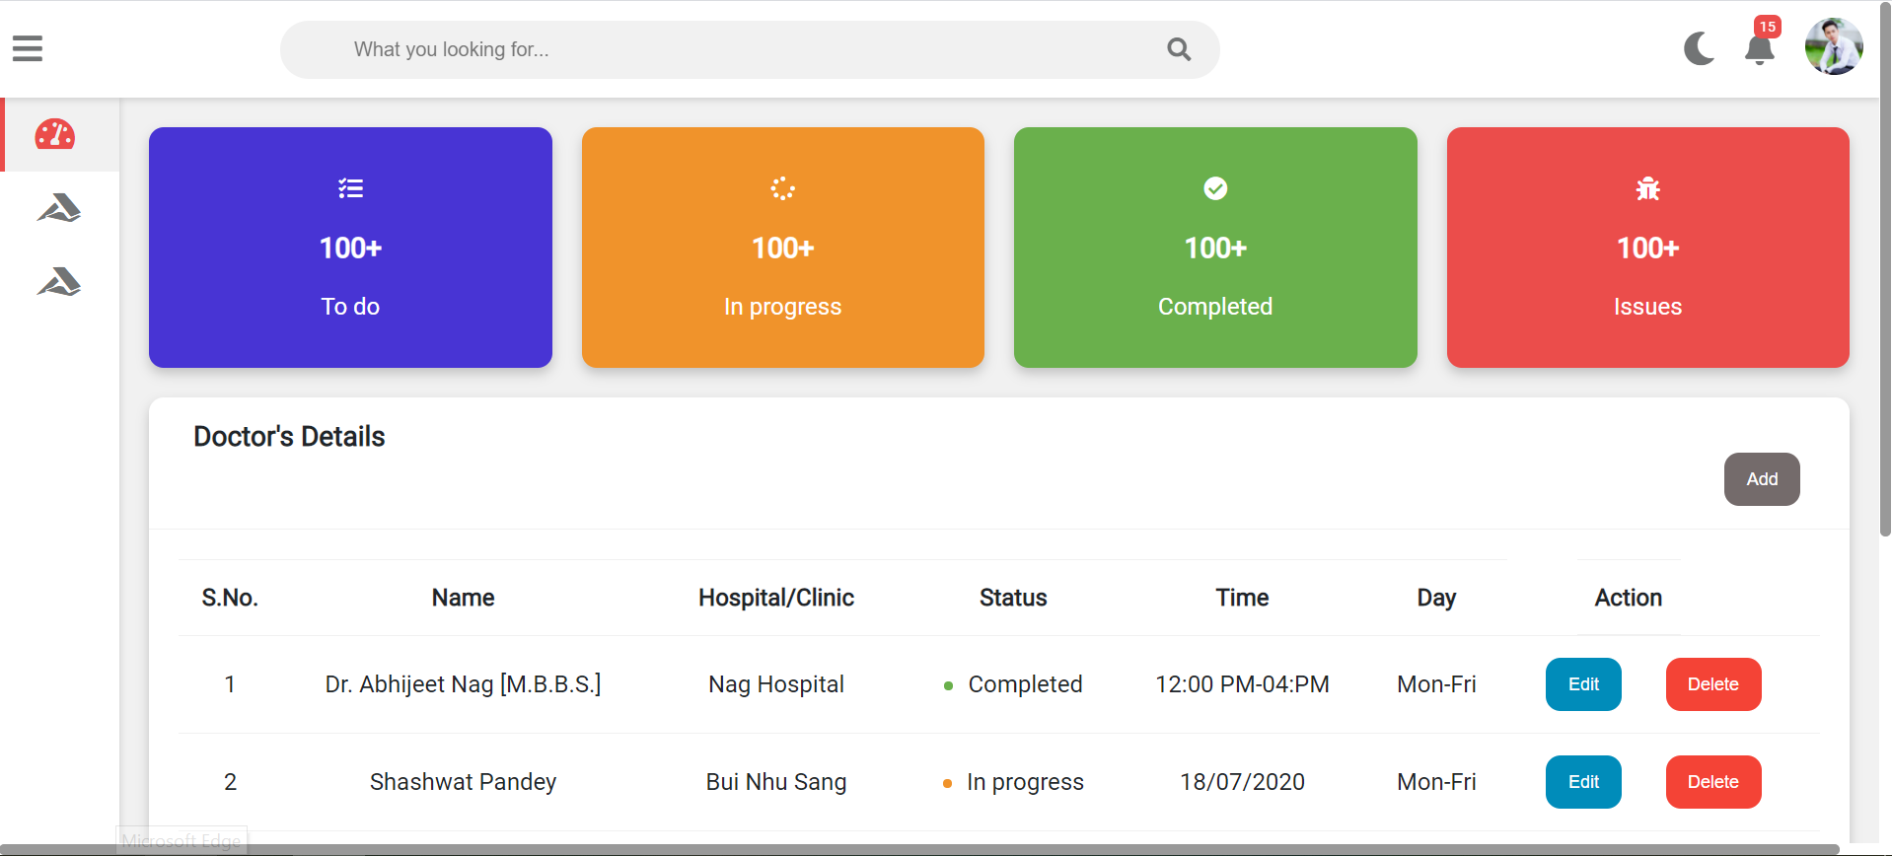

**Hospital Management System**

1. **Splash Screen:**

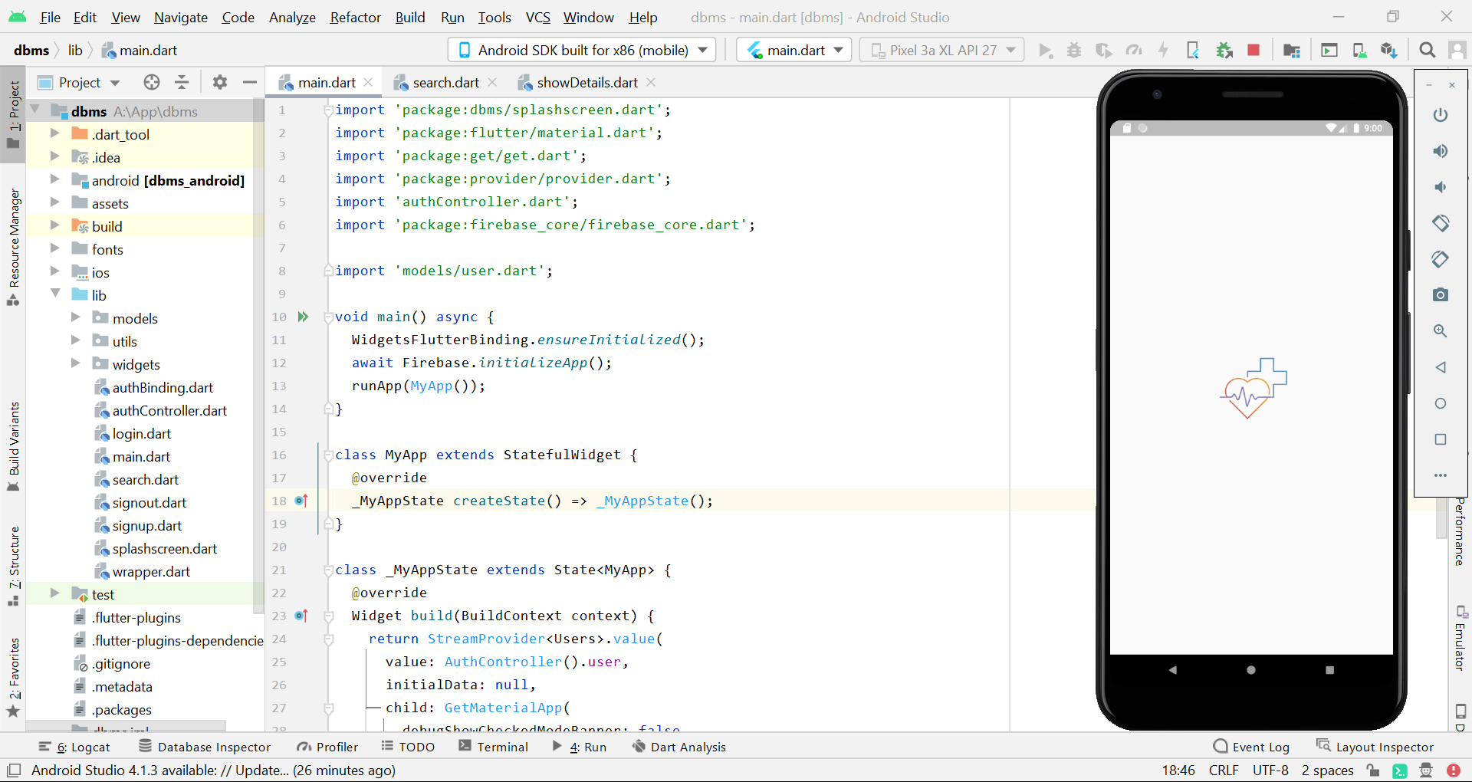

1. **Login Screen :**

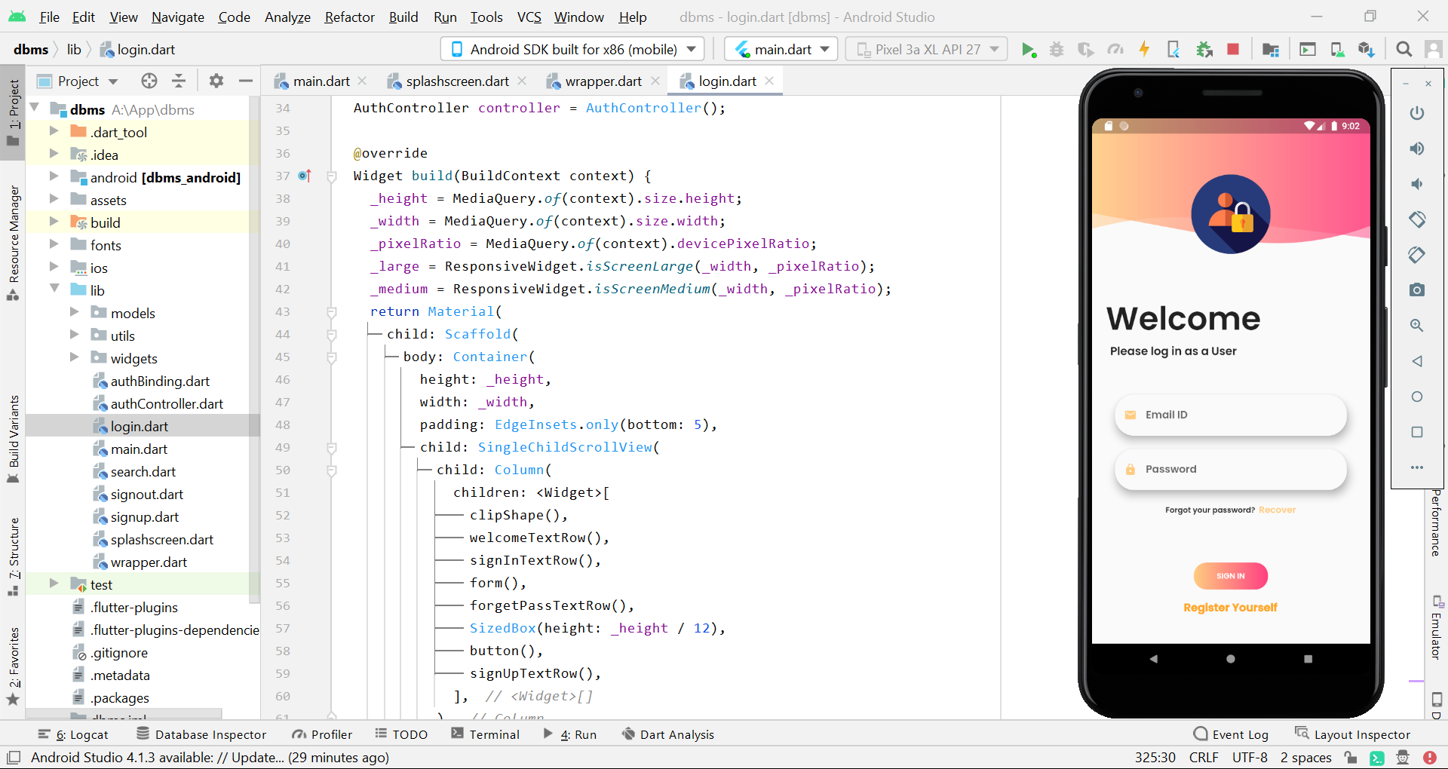

1. **Sign up Screen :**

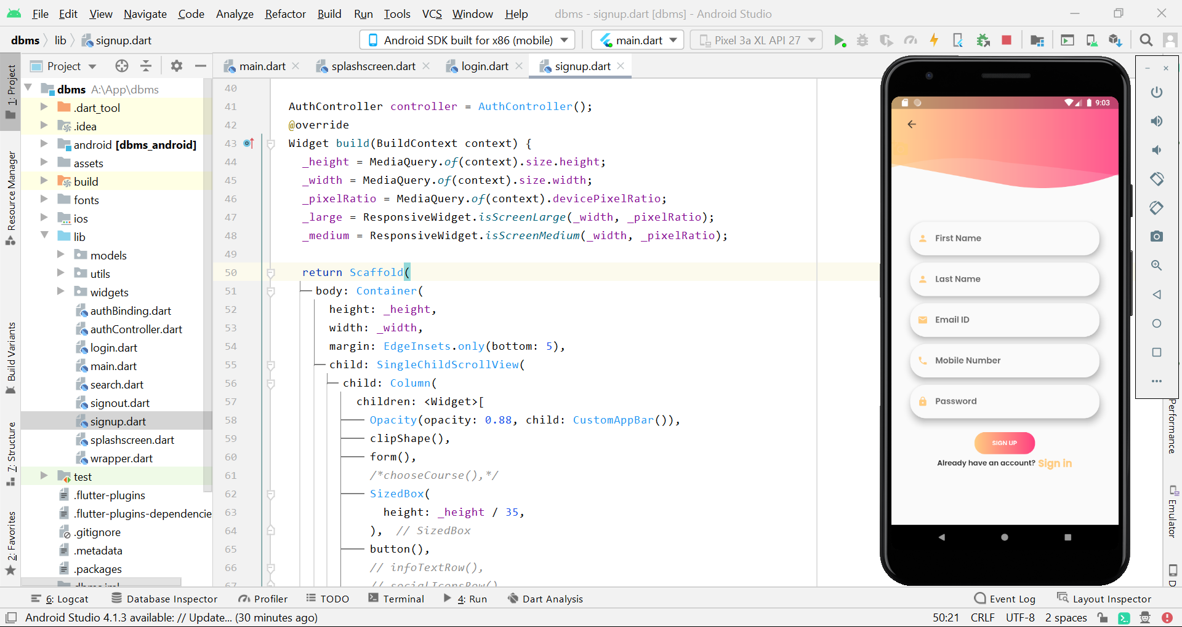

1. **Search page :**

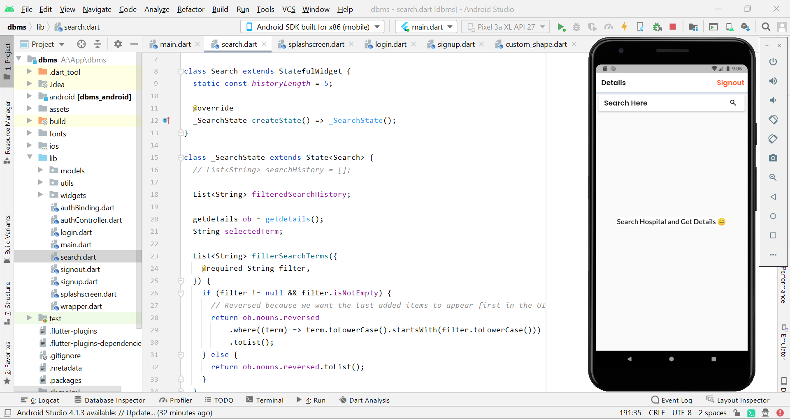

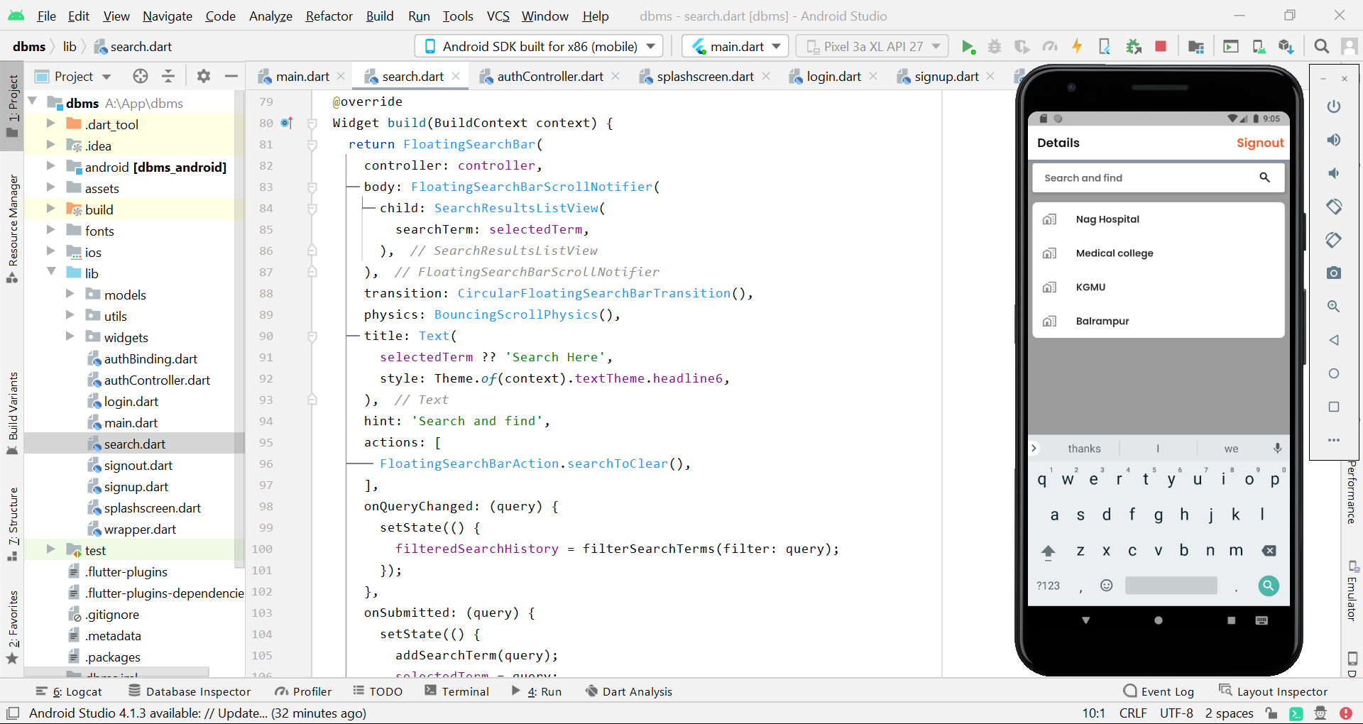

1. **Reset Password :**

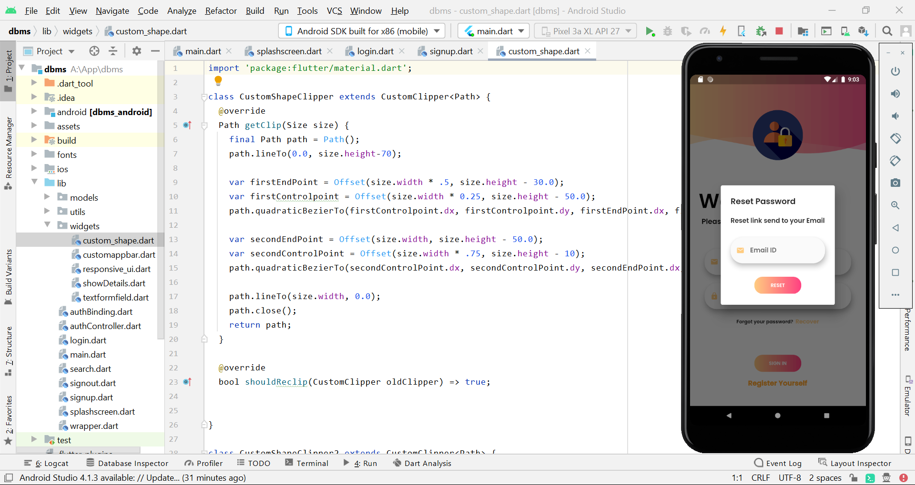

1. **Hospital Name:**

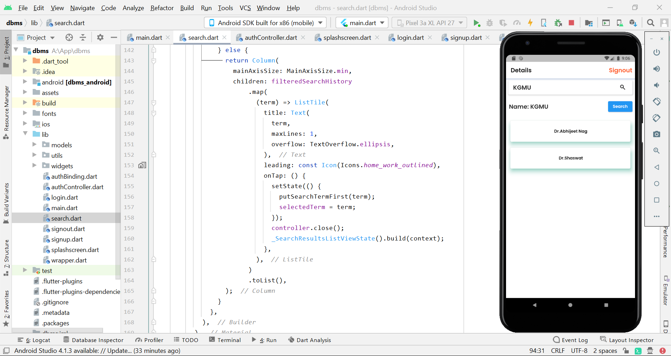

1. **Doctors Details:**

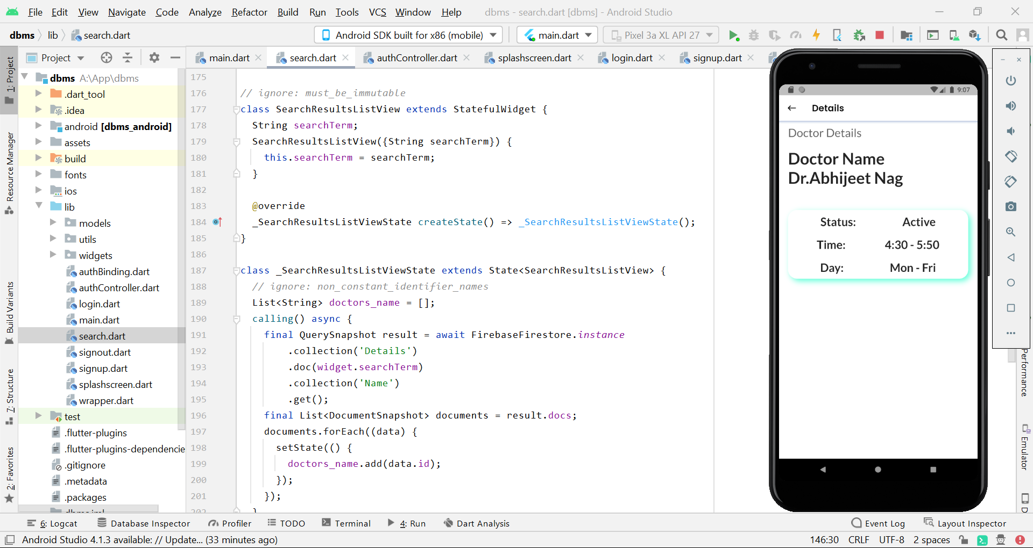

**Hospital Management System UI:**

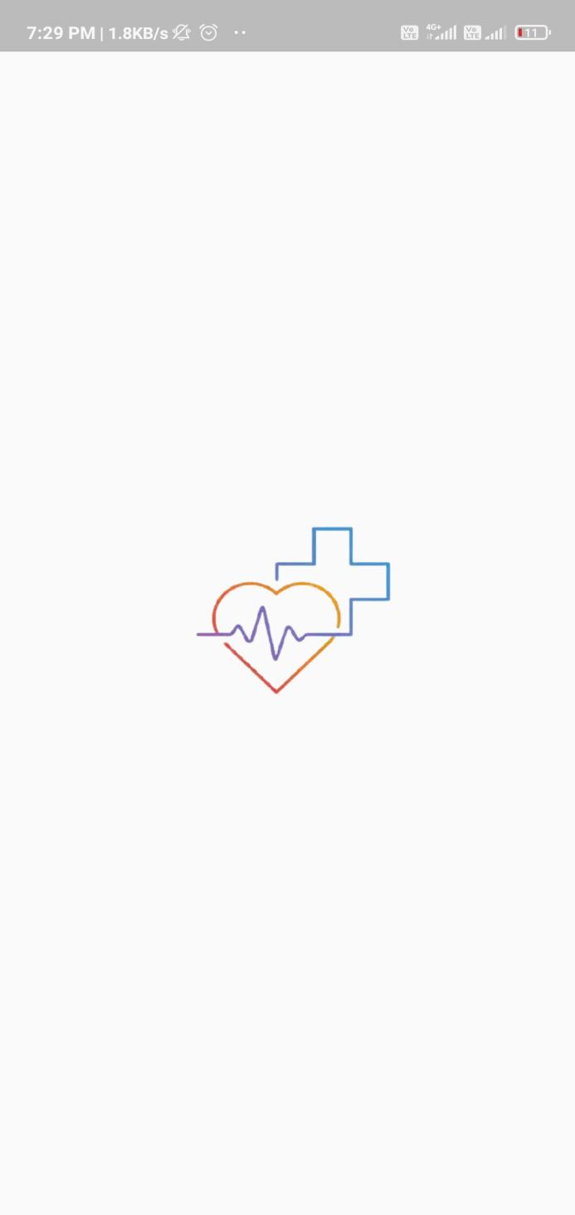

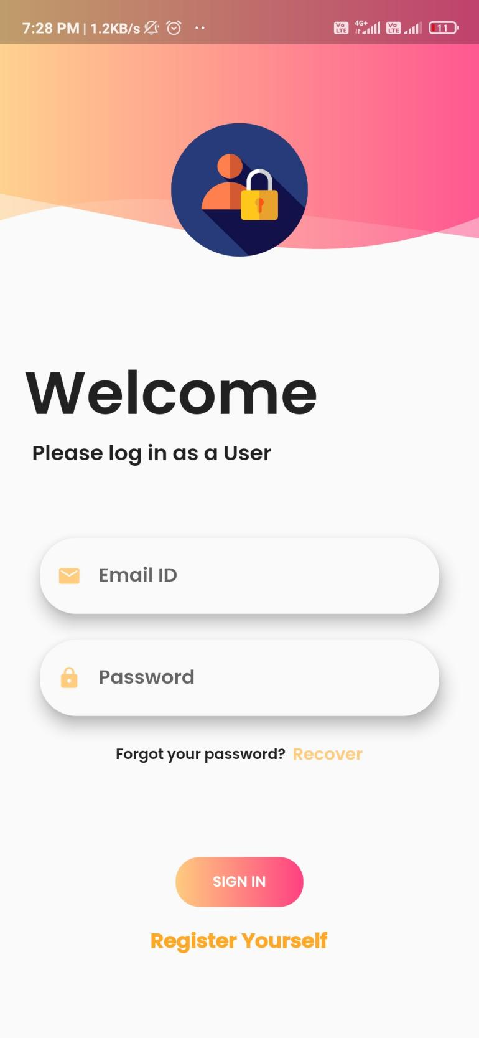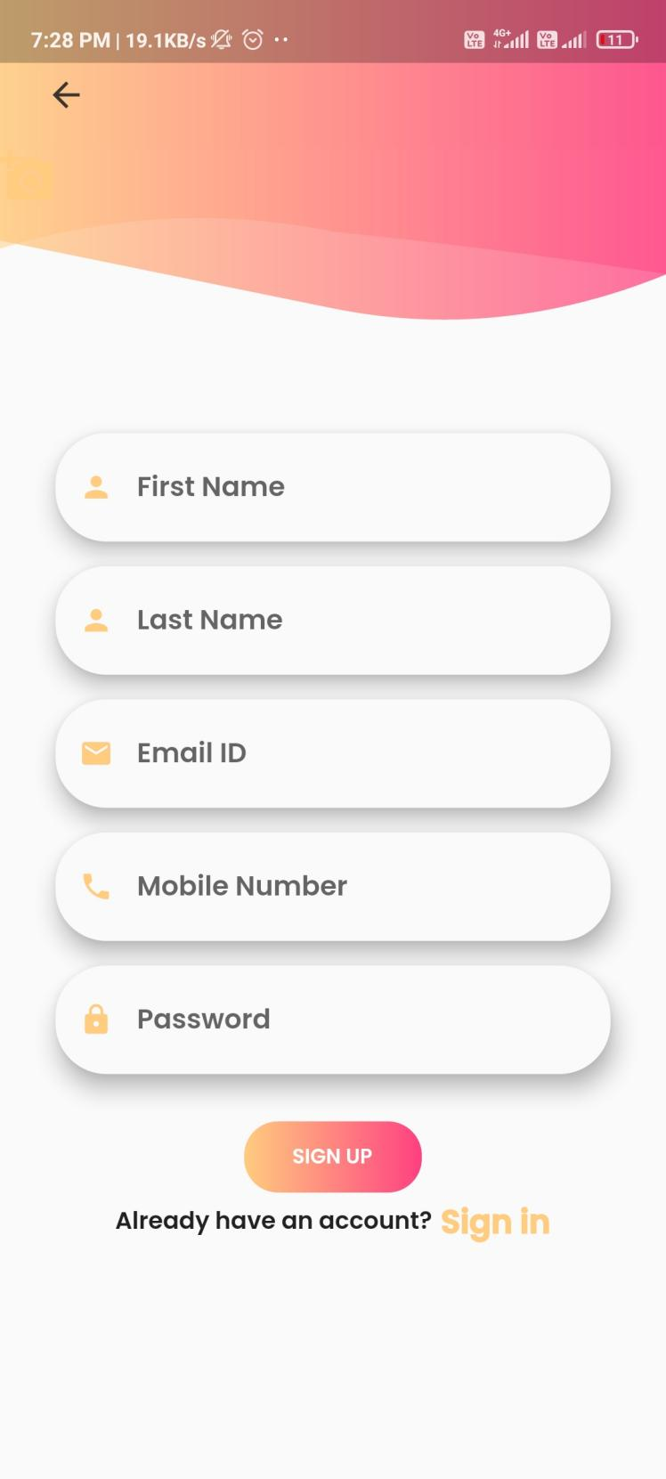

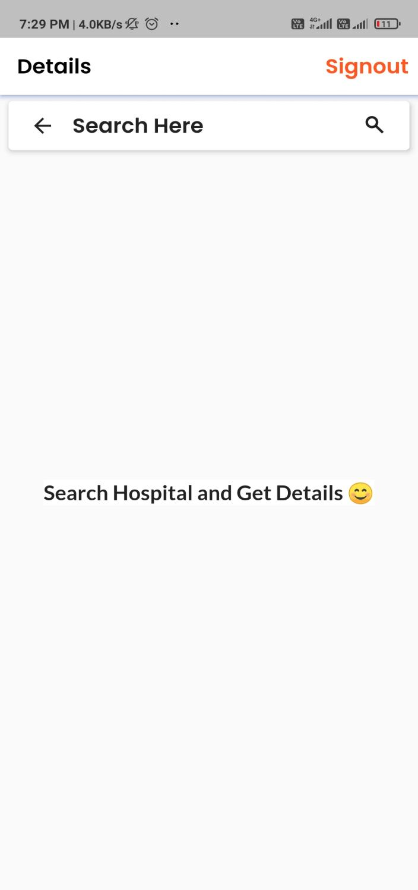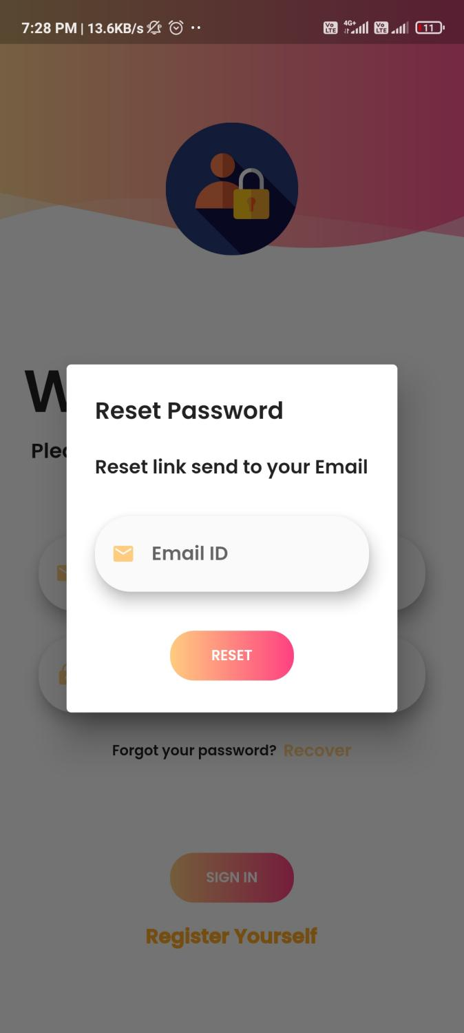

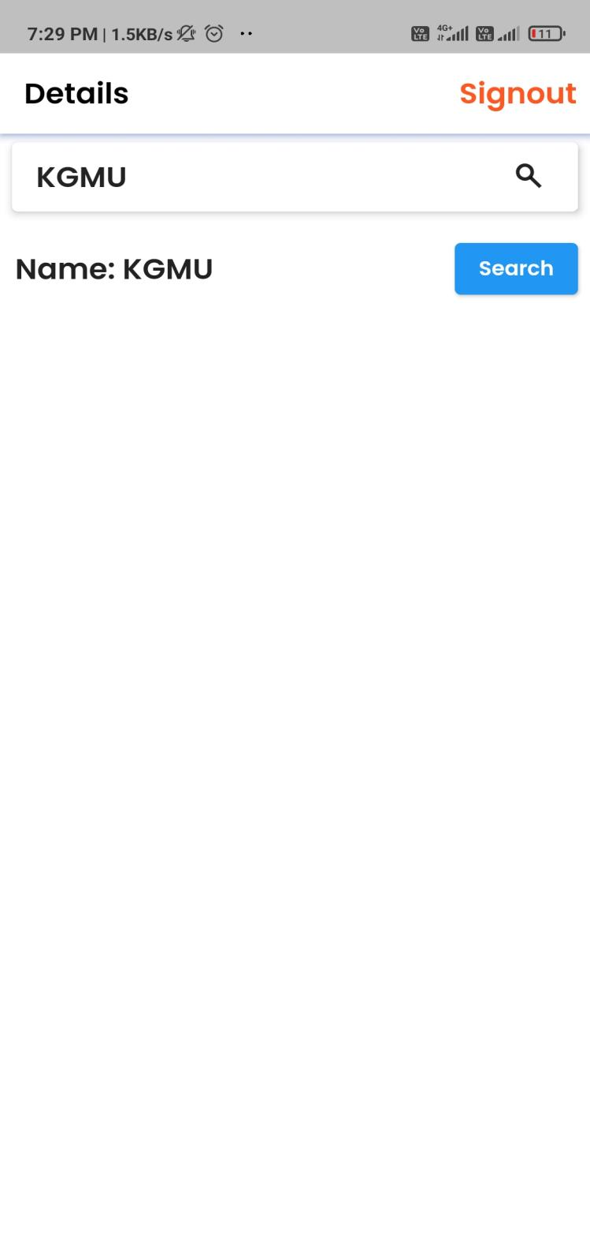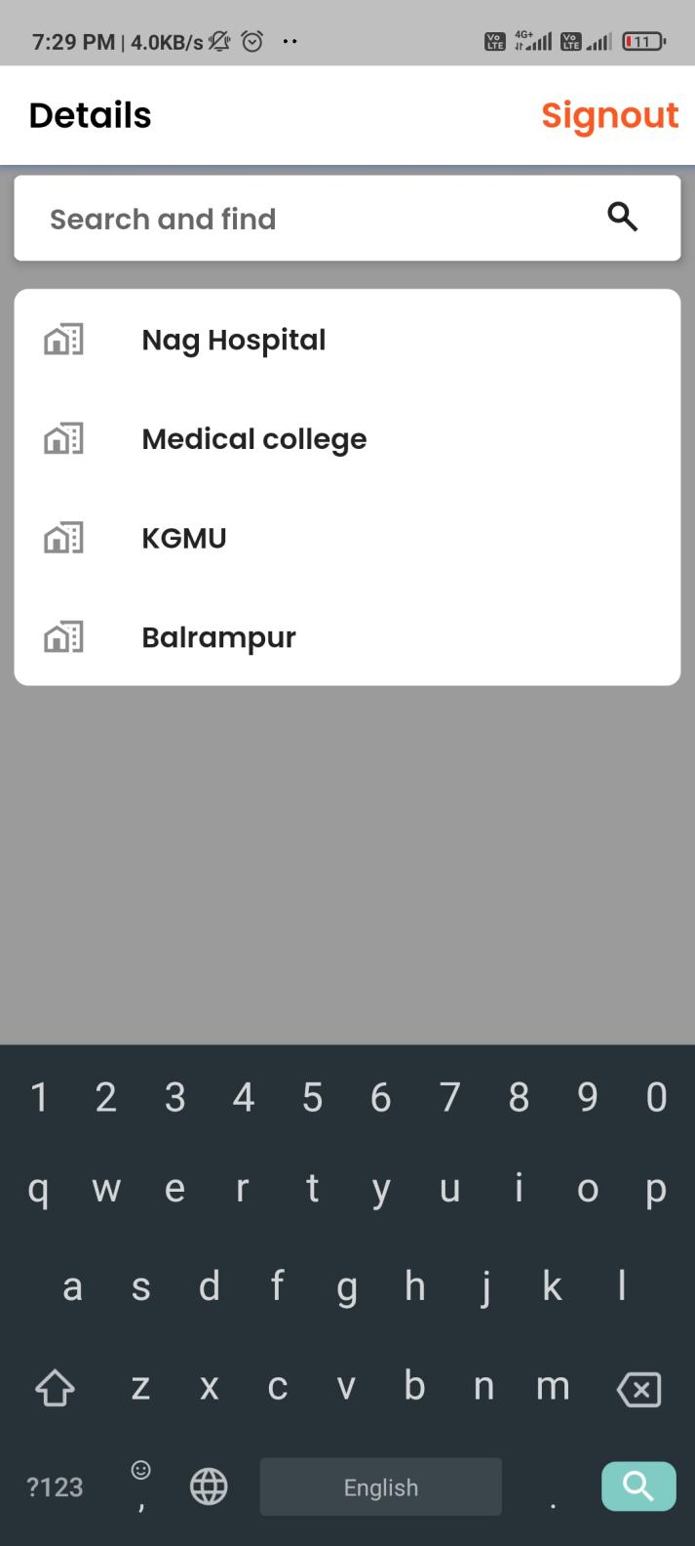

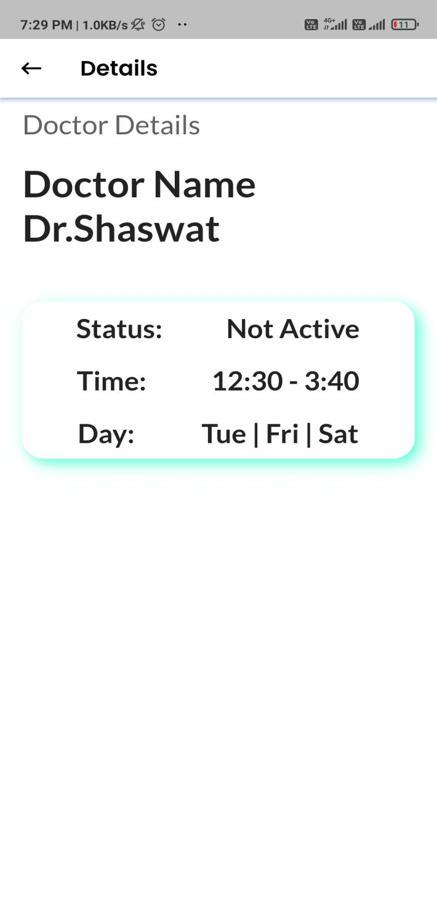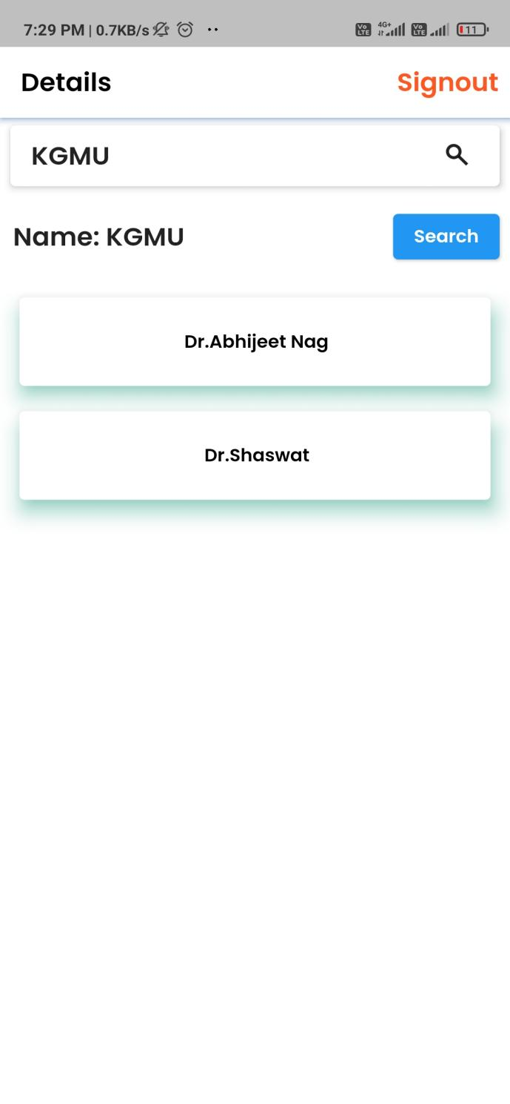

**ADMIN PANEL USING HTML,CSS,NODEJS AND MONGODB.**

1. **HTML :** The Hyper Text Markup Language, or HTML is the standard markup language for documents designed to be displayed in a web browser. It can be assisted by technologies such as Cascading Style Sheets and scripting languages such as JavaScript.
2. **CSS :** Cascading Style Sheets is a style sheet language used for describing the presentation of a document written in a markup language such as HTML. CSS is a cornerstone technology of the World Wide Web, alongside HTML and JavaScript.

**3.NODEJS :** Node.js is an open-source, cross-platform, back-end JavaScript runtime environment that runs on the V8 engine and executes JavaScript code outside a web browser.

**4.MONGODB :** MongoDB’s document data model naturally supports JSON and its expressive query language is simple for developers to learn and use. Functionality such as automatic fail over, horizontal scaling, and the ability to assign data to a location are built-in.

**FIREBASE**

Google Firebase is Google-backed application development software which allows developers to develop **Android, IOS,** and **Web apps**. For reporting and fixing app crashes, tracking analytic, creating marketing and product experiments, Firebase provides several tools.

Firebase has three main services, i.e., a real-time database, user authentication, and hosting. We can use these services with the help of the Firebase iOS SDK to create apps without writing any server code.

**COMPANY DETAIL**

This application named “DATABASE MANAGEMENT SYSTEM” gives the details of the doctors that is available is that hospital. When user wants to search for a hospital, user can easily see doctors without any interpretation. On the front, user will see the details and on the other side, user can book the appointment.

**REFERENCE :**

• [www.wikipedia.org/](http://www.wikipedia.org/•)

[•](http://www.wikipedia.org/•) [www.udemy.com/](http://www.udemy.com/)

• www.google.com/